**Dr. D. Y. Patil Institute of Engineering, Management & Research, Akurdi, Pune-44**



**OOPL Assignment Book**

**Submitted By**

|  |  |  |
| --- | --- | --- |
| Roll.No | Name | Div/class |
| SEAD21171 | Nirmal Avhad |  |



**DEPARTMENT OF COMPUTER ENGINEERING**

**ACADEMIC YEAR 2021-22**

1. **Statement:- IF(1<N<=9) , PRINT THE LOWERCASE ENGLISH WORD CORRESPONDING TO THE NUMBER (E.G., ONE FOR , TWO FOR , ETC.).**

**IF(N>9) , PRINT GREATER THAN 9.**

Code:-

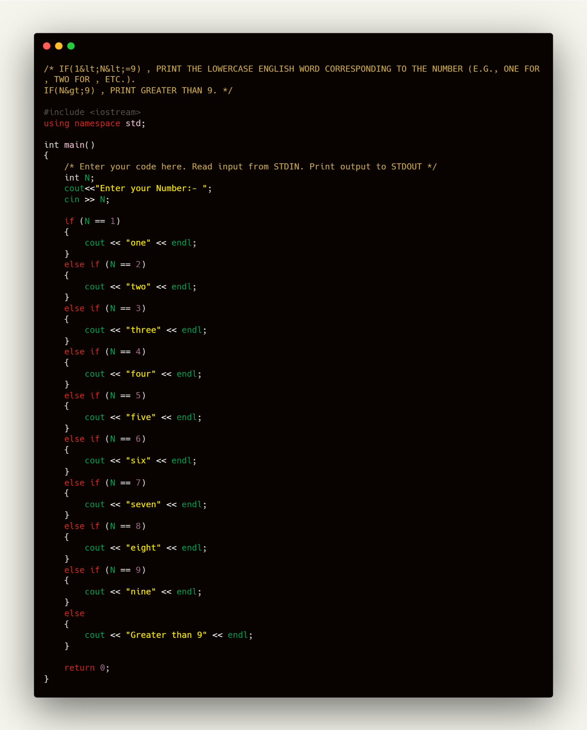

OUTPUT:-

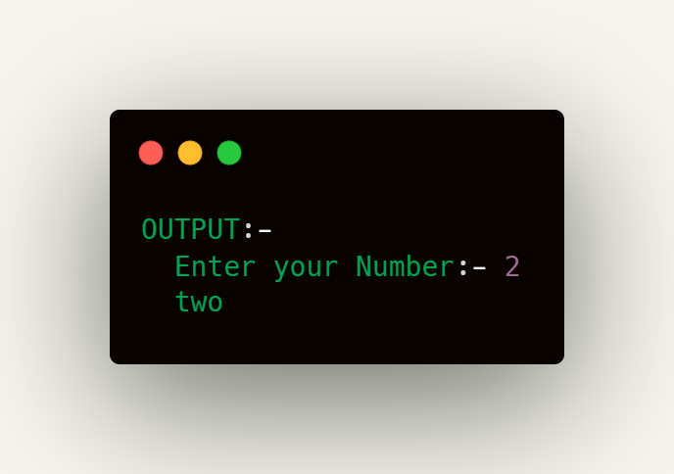

**2.Statement:- Given an integer, N , print its first multiples. Each multiple N*i (where 1<=i<=10) should be printed on a new line in the form: N x i = result.**

**CODE:-**

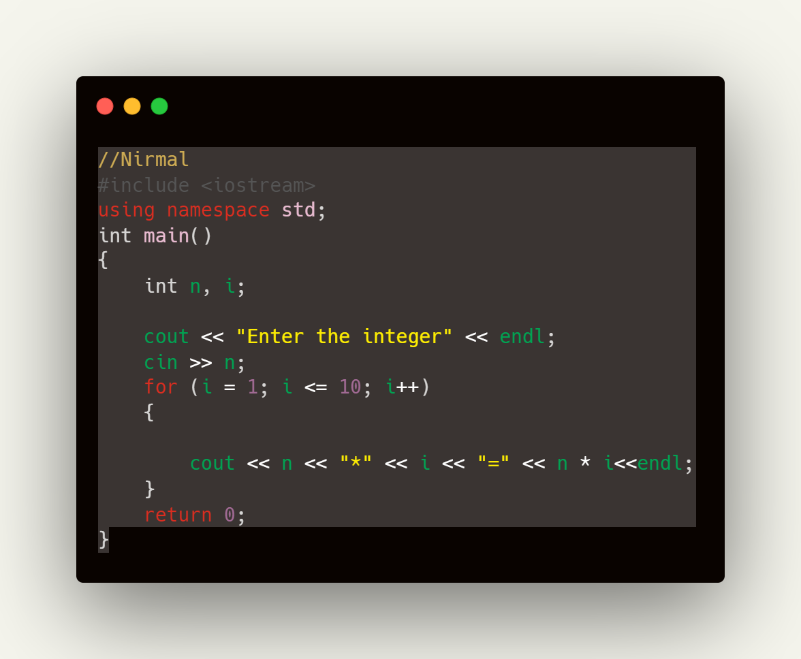

OUTPUT:-

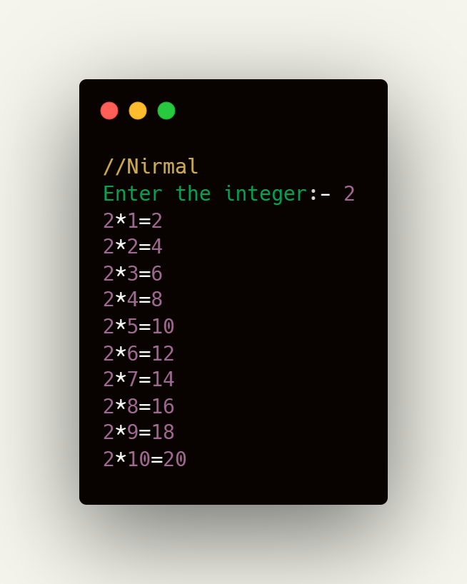

**3.Statement:- C++ Program To Print Reverse Order And Print Sum Of Its Element Of An Array.**

**CODE:-**

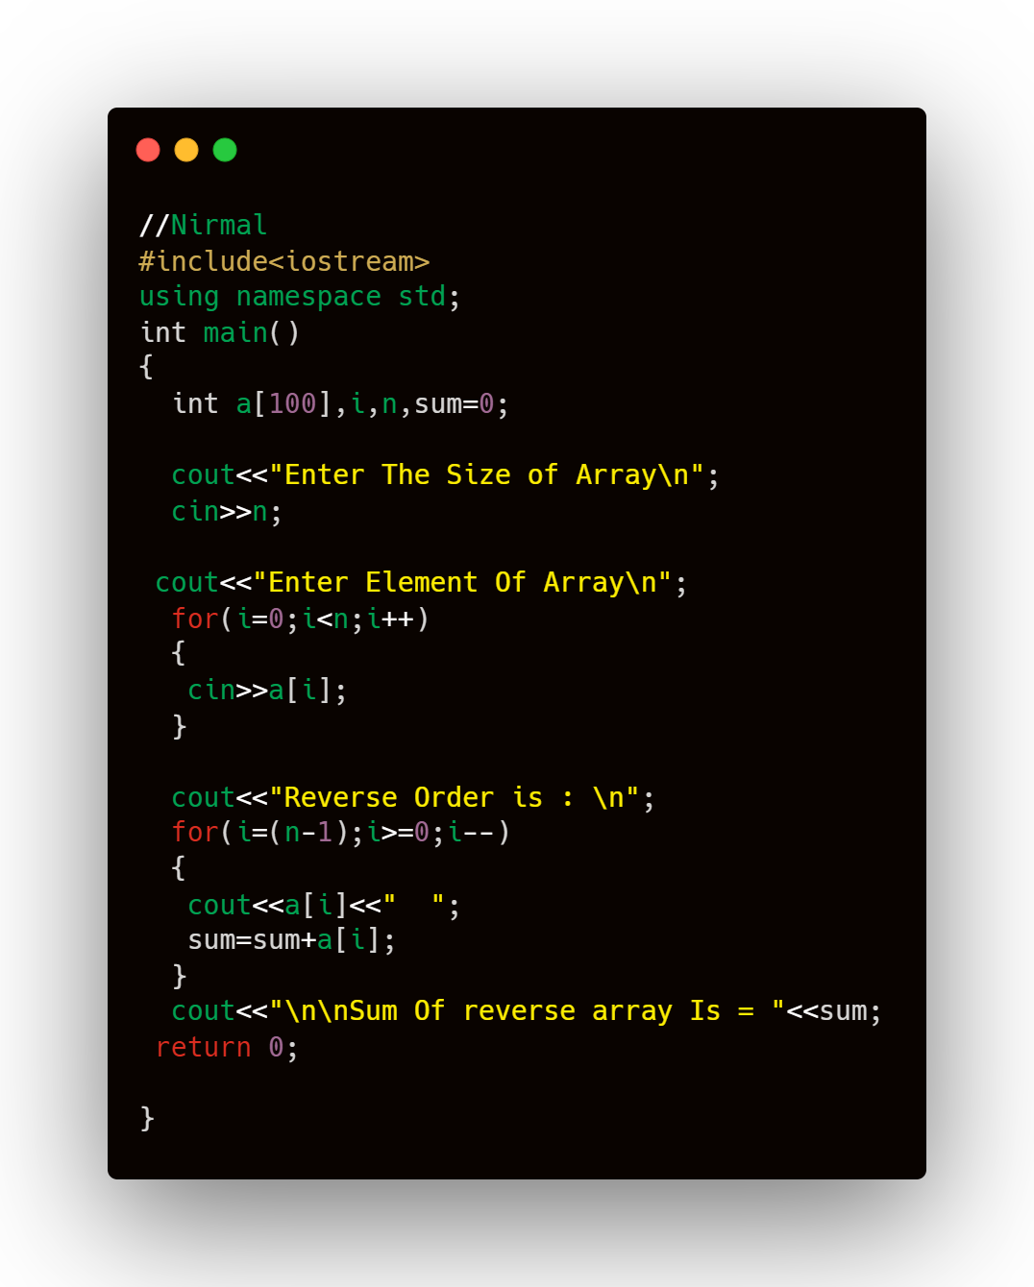

**OUTPUT:-**

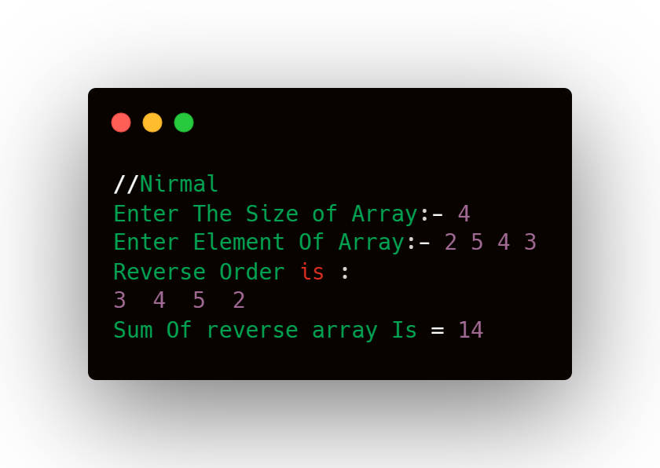

**4. Statement:- Write a program in C to find the maximum and minimum element in an array.**

**CODE-**

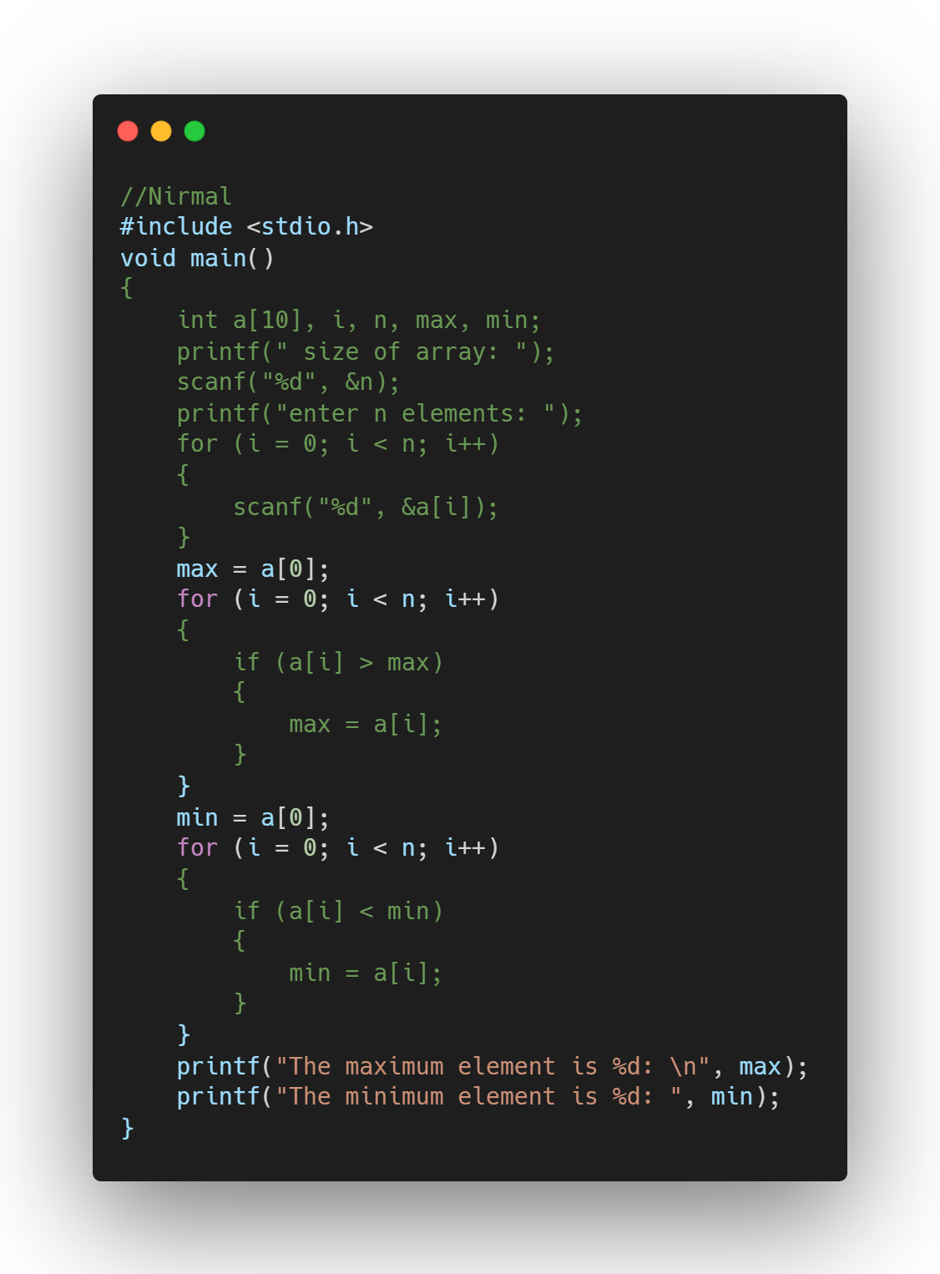

**OUTPUT:-**

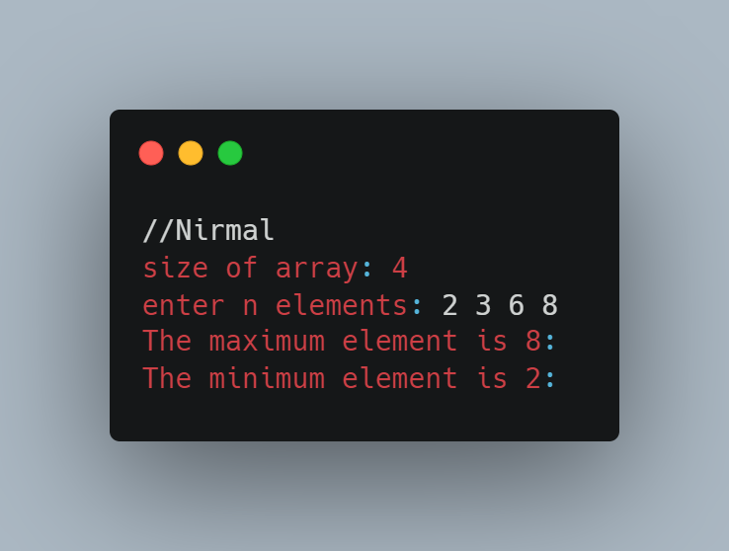

**5) Inheritance:**

**i) Single Inheritance**

* **Write a C++ program to derive Single Inheritance to calculate cube of number Base class: Class Value**

**Sub class : Class Cube (x*x*x)**

**CODE:-**

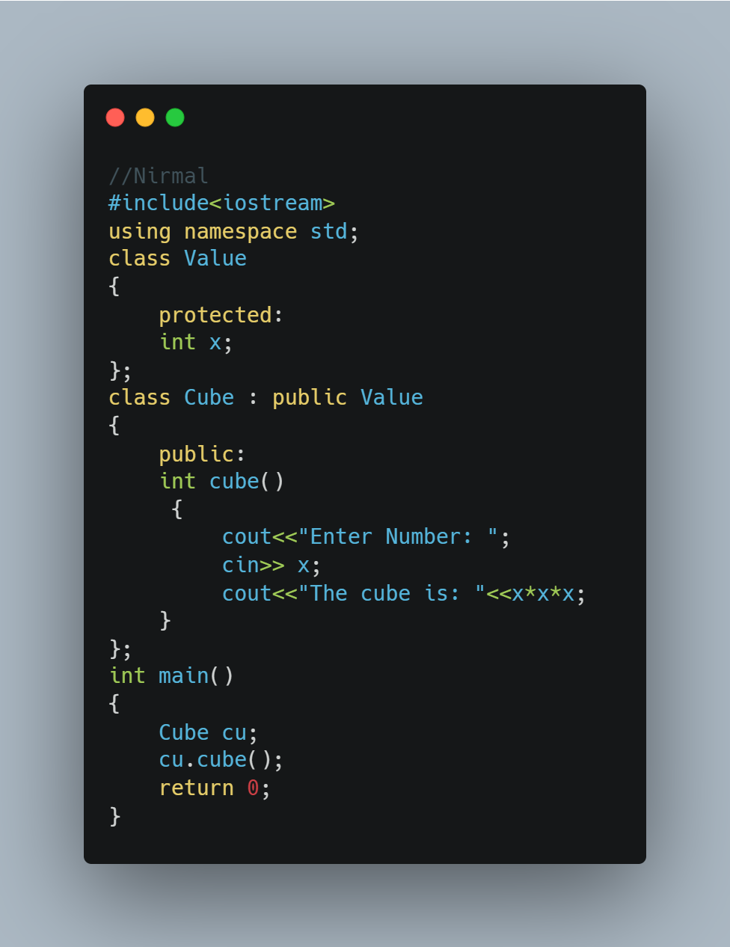

**OUTPUT:-**

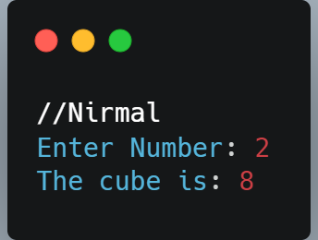

**ii) Multiple Inheritance**

* **Write a C++ program to implement Multiple Inheritance**

**Base Class1: Triangle🡪data members: base, height**

**member function: gettri(); //retrive values of height &base from user**

**Base class2:Rectangle🡪data members: length,bredth**

**member function: getrect(); // retrive values of length & bredth**

**Sub Class: Shape🡪 data member: area**

**member function: areatri() and arearect()**

**Triangle: 0.5*base*height**

**Rectangle: Len*bre**

**CODE:-**

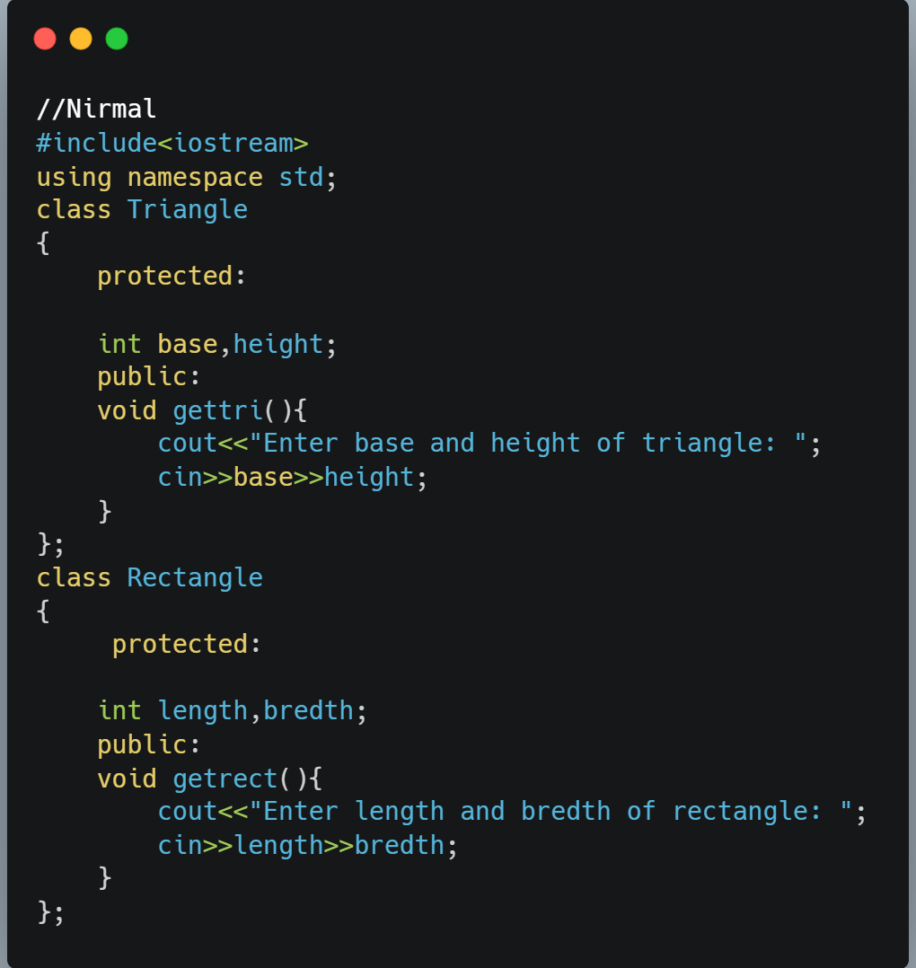

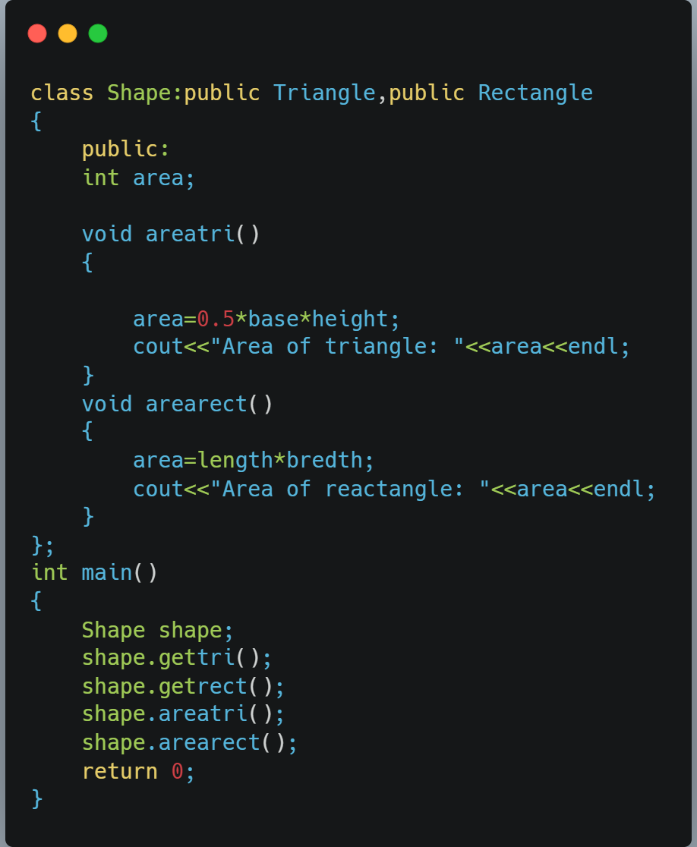

**OUTPUT:-**

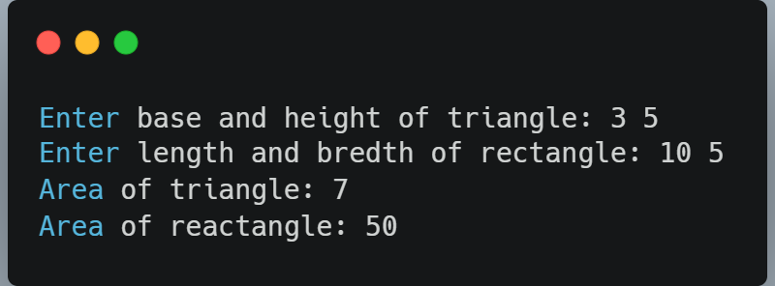

**iii) Multilevel Inheritance**

**Implement Multilevel Inheritance**

**Class1: Name🡪 data member: Nm**

**Member function: get_name();**

**Class2: Parent 🡪 data member: pnm**

**member function: get_pname();**

**Class3: Surname🡪 data members: surn**

**member function:get_surname() and Display();**

**CODE:-**

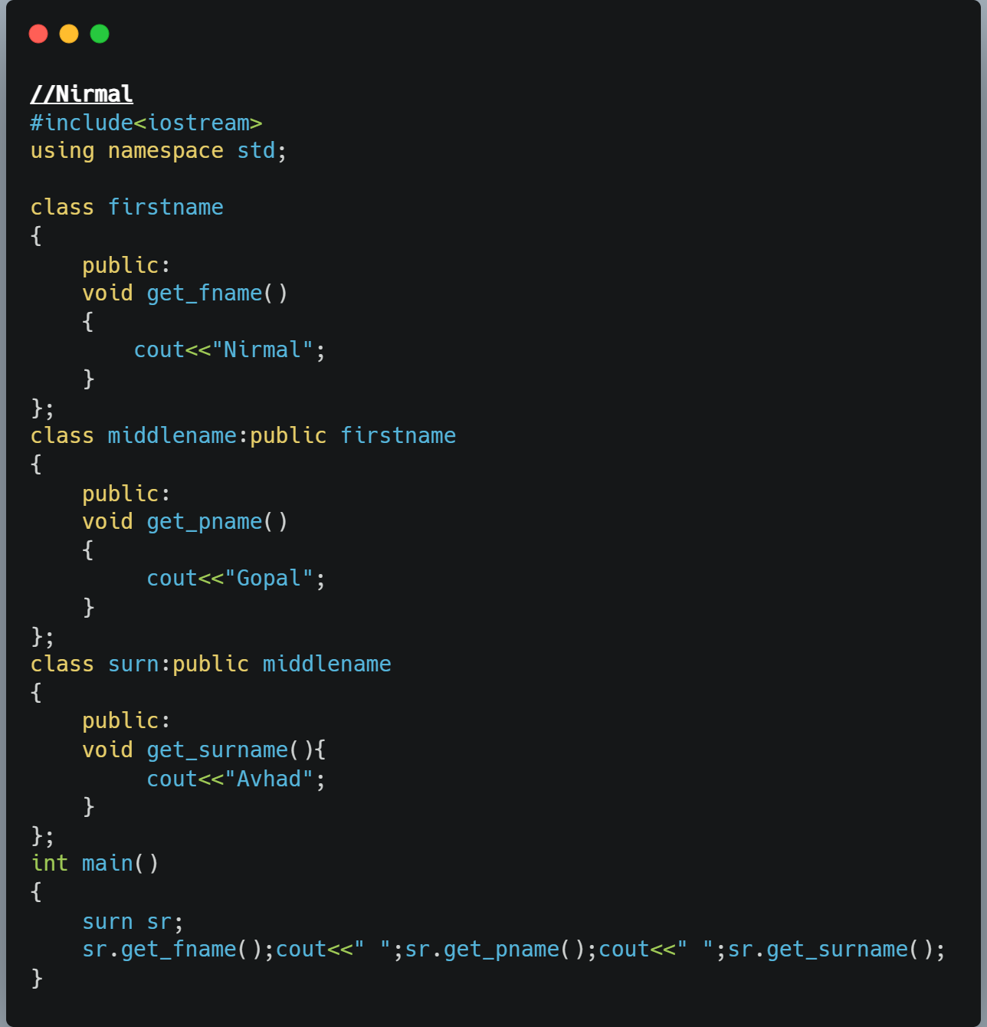

**OUTPUT:-**

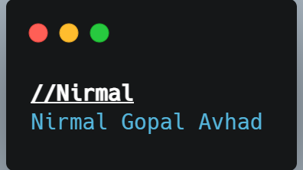

**iv) Hierarchical Inheritance**

**Class: Account🡪 data members :accno, name**

**member function🡪 read(), show()**

**Sub class1🡪 Saving Account🡪 data members : int rate of interest**

**member function🡪 read(), show()**

**Sub class2🡪 Current Account🡪data member: int odlimit**

**member function🡪 read(), show()**

**CODE:-**

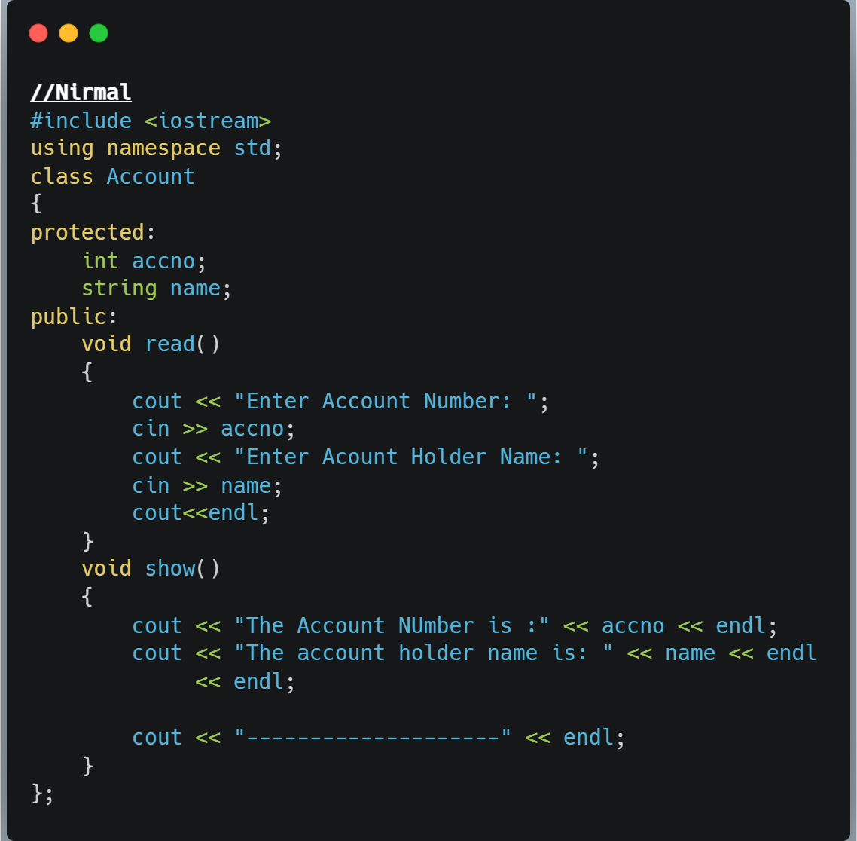

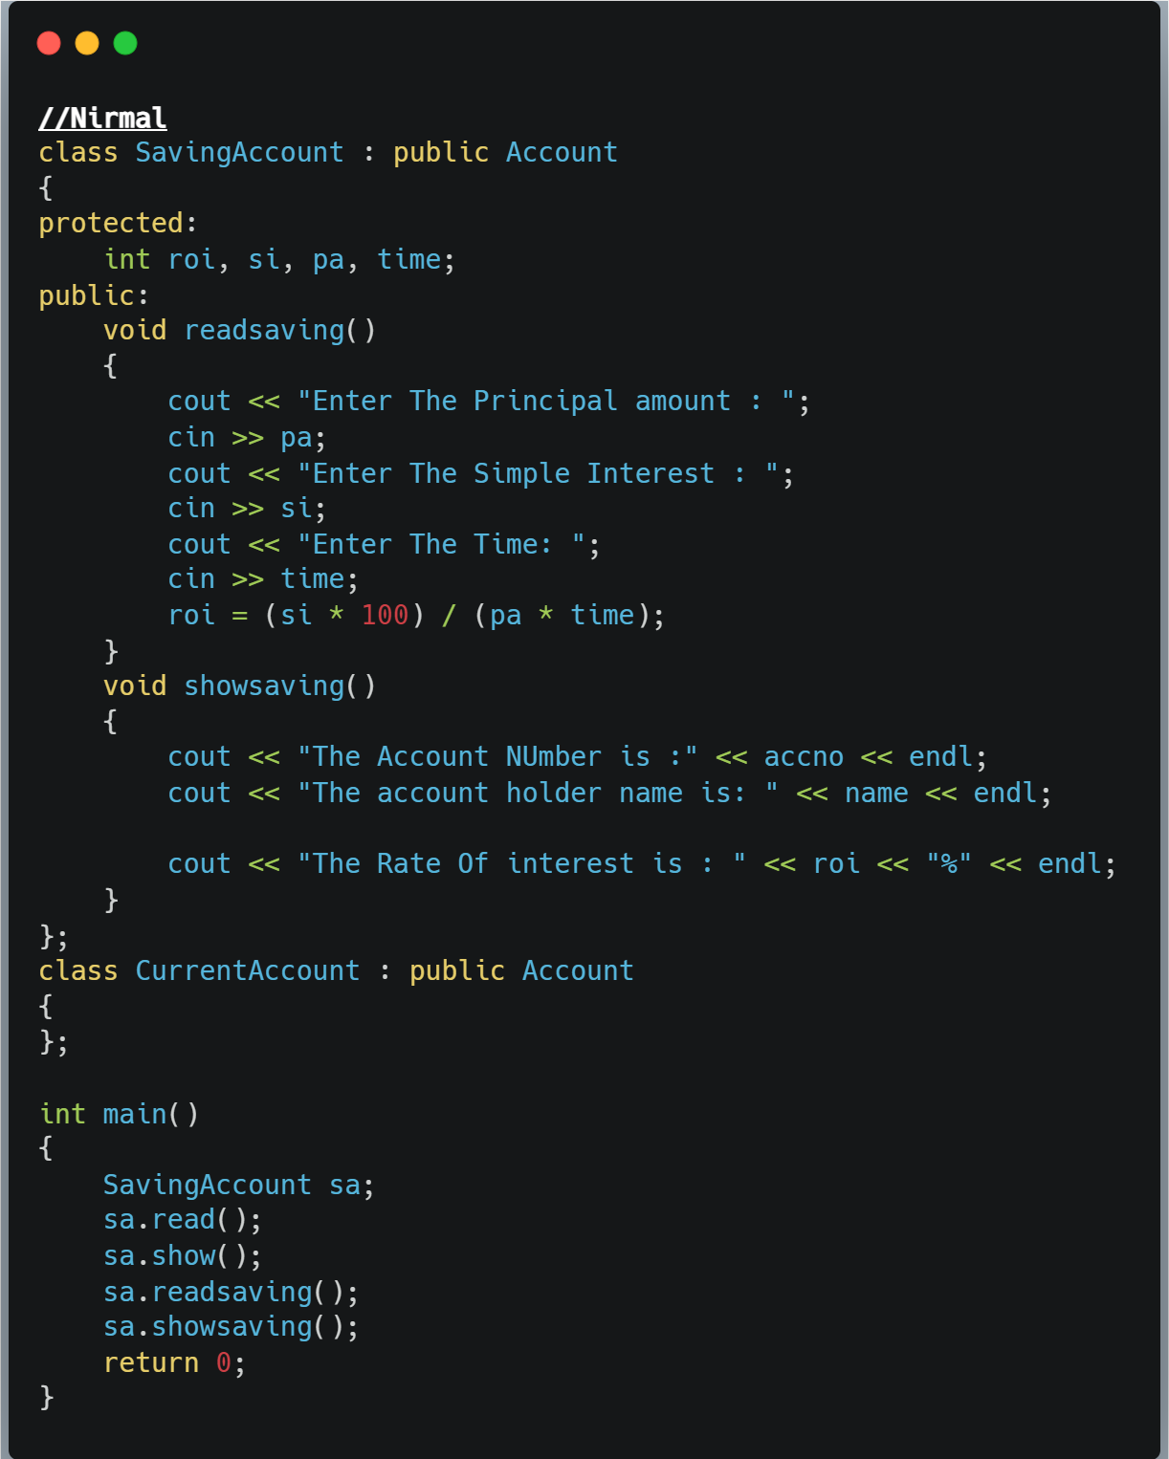

**OUTPUT:-** 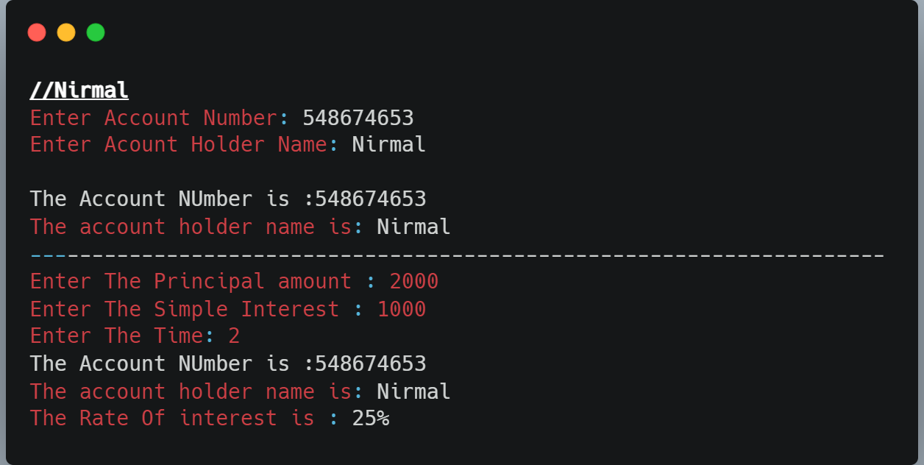

**v) Hybrid Inheritamce**

**Class Student🡪 data members: roll, name**

**member function: read(), show()**

**Class Exam🡪data members: marks1**

**member function: read(), show()**

**Class sports🡪 data members: marks2**

**member function: read(), show()**

**Class result🡪 member function: read(), show()**

**call all methods in result class and calculate total marks**

**CODE:-** 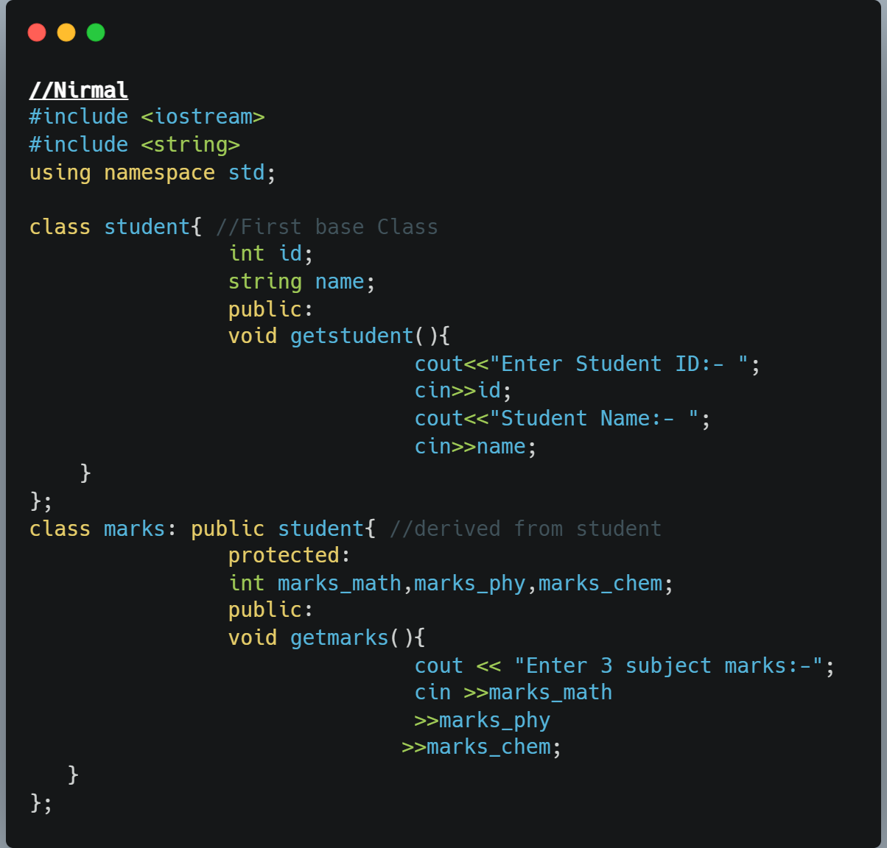

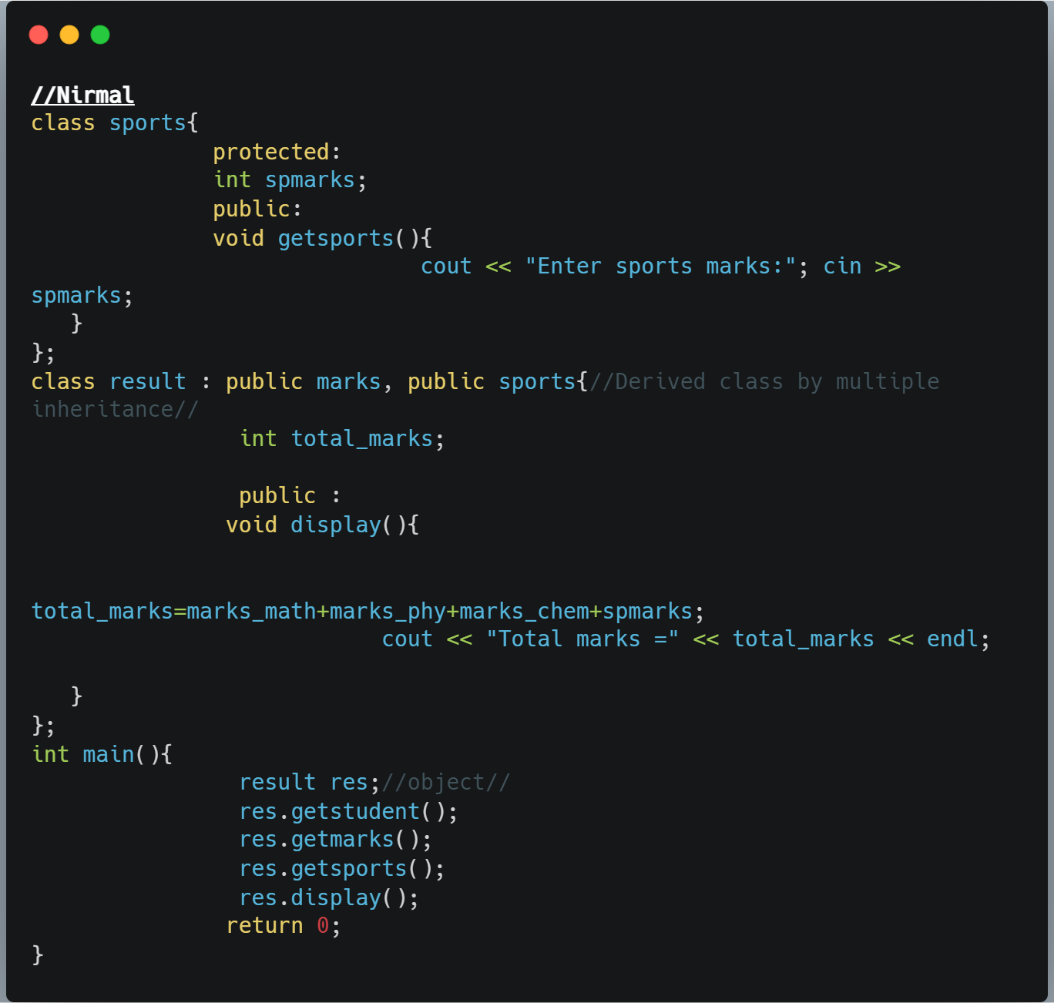

**OUTPUT:-**

